**HALL BOOKING SYSTEM SRS**

**UML DIAGRAM**

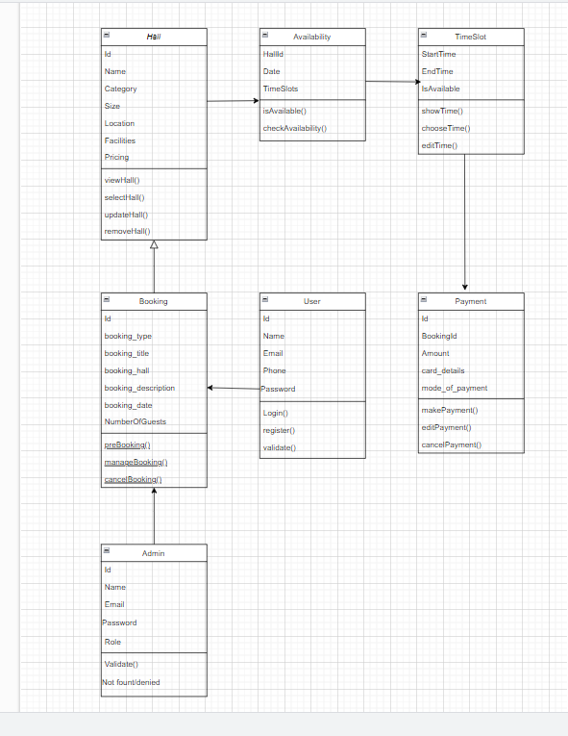

***ER DIAGRAM***

